Lockington Parish Council
Report on Highway Flooding on the 18th of September 2023
I was asked to make a report to the LPC on the Flooding in Lockington on 18th September 2023. This will be considered by the LPC at their next meeting in October and used in submissions to ERYC and the EA.

The flooding resulted from a relatively short period of very heavy rain in the early hours of September 18thof 2023 commencing about 0400hrs and it stopped around 0830hrs.

The areas most affected were the West and East end of Front Street, Dead Lane, Thorpe between Bealeys Lane and Church Lane and Church Lane opposite number 23. (Area 1-5 on the map below)

Most noticeably compared to previous flooding in 2007 and 2019/2020, Thorpe Rd and the entrance to Church Lane was not a crisis point because of the improvements made by the ERYC.

As before, thanks are extended to those who turned out to clear the drains in all parts of the village. Without this help the water accumulation would undoubtedly have been far worse. In many cases those responsible were VFW’s but many other residents also contributed.

West end of Front Street: (Location 1 on the map below). The worst flooding with the potential greatest impact was at the west end of Front Street. (Location I on the Map) The water was sufficiently deep to make the wash from passing vehicles a serious risk to nearby houses as was found when a tractor and school bus passed. Water enters the Beck from the fields to the west of the village and down Kilnwick Hill. There is little that can be done in the short term to alleviate this water flow. The LPC should however inform the EA that a long-term solution needs to be found. For example, the culvert to be “dammed” along the valley with a permanent pipe in its base to allow normal drainage but to hold up any surge such as that on the 18^{th.}
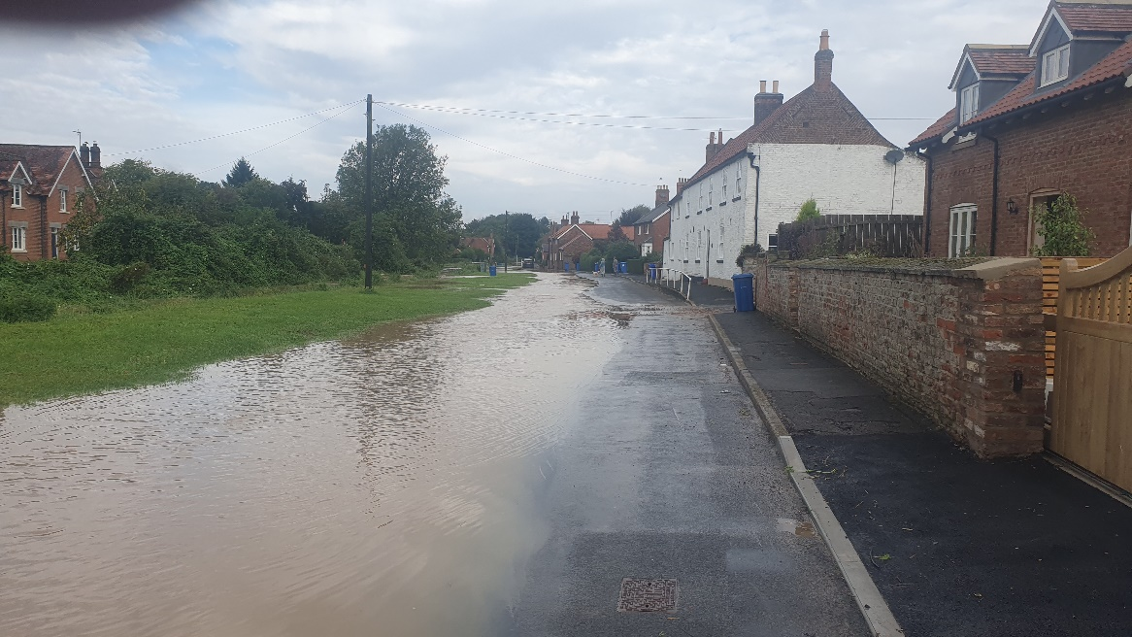

East End of Front Street. (location 2 on the map) The drainage that collects the water on both sides of the road and runs it by the side and under the road to a drainage ditch on “Grants” field. It needs to be cleared and upgraded and the capacity of the ditch that carries the water to the Beck looked at. The manholes on the south side of the road need investigation to fully understand what role they play in diverting the water. This now becomes the priority area of concern for the LPC. LPC to contact EA and ERYC who have highway responsibility. Ward Councillor J Wilcock has asked for a copy of the report in order to follow up on behalf of the LPC.
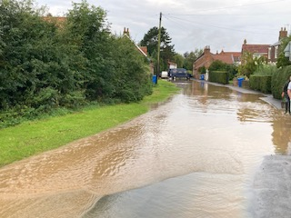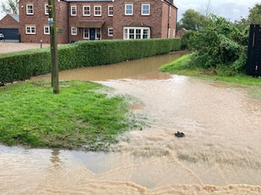
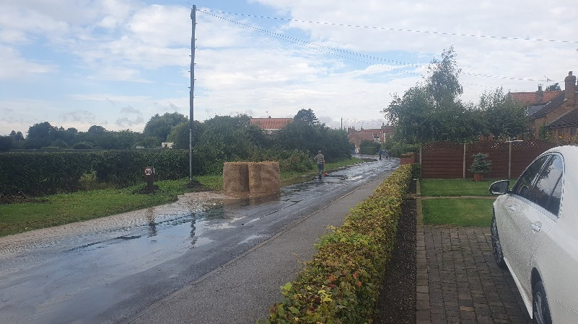

Dead Lane: (Location 3 on the map) Although Dead Lane flooded to some considerable depth, the water is held up until it finds its way into the culvert that then runs under Thorpe Leys and into the “new” Pipelines at the junction of Thorpe and Church Lane. The fact that it is held up can be considered positive in preventing the system being overloaded so long as the neighbouring properties are not adversely affected. The water had largely gone and the lane was passable by lunchtime.
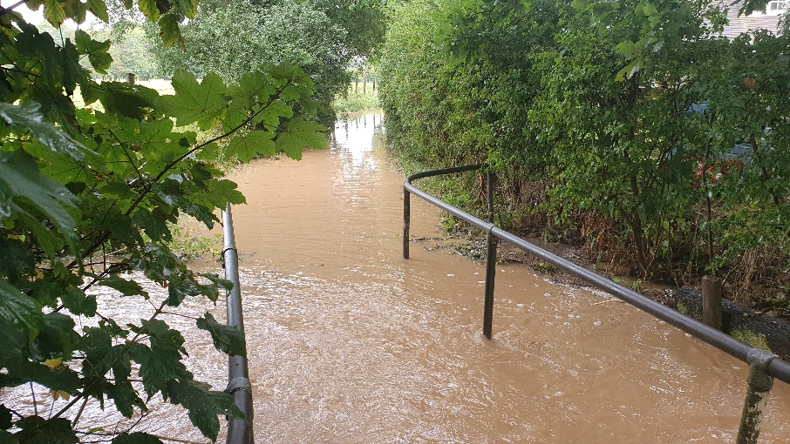

Thorpe: Bealeys Lane to Church Lane. (Location 4 on the map) There was extensive flow of water at peak. It did disperse more quickly than that at the west end of Front Street. Again, clearance of the grids by local VFWs/ residents was critical in keeping the water flowing. One of the under-road drains is blocked (the culvert under Thorpe from the electric pole to East Thorpe Cottage. LPC to follow up with ERYC.
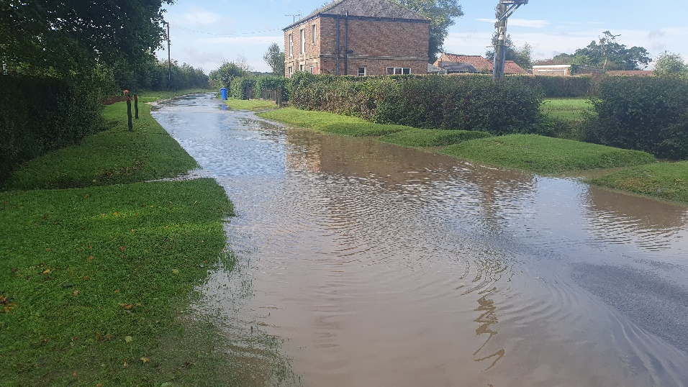
Local observation is that if the grills can be kept clear, although the road will be flooded the water will eventually get away into the culvert behind the houses on Church Lane as it did in 2007.Excess water flows down Church Lane and should join the water coming down the culvert to enter the underground pipe that takes the water to the beck. The pipe cannot handle the volume, so it overflows and joins the water coming down the road to form a stream that runs down the side of the house into the garden of 23A as a temporary torrent. (Location 5 on the map) LPC to flagged up to the EA/ ERYC as a major concern to be investigated.
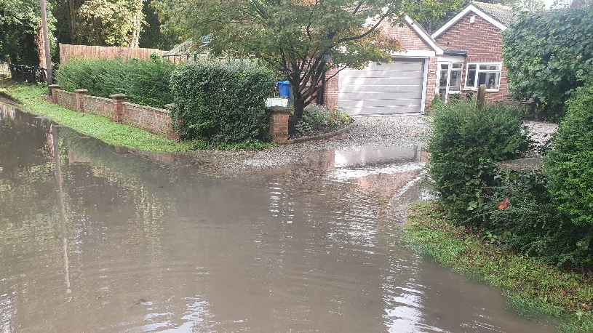
Weed control in Beck: the EA should be clearing this three times per year, as previously agreed. Three weeks prior to this a resident had had concerns and rung the EA asking when it would be cleared. Reports indicated that how this is done depends on the team on the day and does require more than working from the banks. LPC to remind EA of importance and establish programme for clearance.
LPC/ Village Flood Wardens (VFW) Response. The reason for having VFWs is to have a body of residents who can take a lead in clearing local drains, helping anybody who requires it and generally being proactive.
A list of VFWs with contacts was published some time ago. A valid criticism is that this needs to be updated and republished in the gazette and placed on the village noticeboard.
Another good suggestion is that there should be an annual review of a progress over the year, village Flood Plan and VFWs. (November meetings?)
Questions were raised on local WhatsApp as to whether a “more co-ordinated” action by VFWs could be devised. In the knowledge that we will never know what VFWs are around on the day, there is intentionally no hierarchy at present. Also, local VFWs tend to concentrate on their local part of the village and may only become aware of what is happening elsewhere when they get on the VFW WhatsApp. Nevertheless, the LPC and VFWs should consider this, and suggestions would be welcomed.
With regards to contact with the EA or ERYC. Any resident can do this and there is no harm done if there is some duplication. Contact numbers to be circulated to VFWs?
Traffic Directions and signage. Unfortunately, VFWs or residents can only advise/suggest/ persuade drivers not to proceed through flooded roads even if the wash caused has the potential to damage or even flood a property. On Monday morning some drivers wishing to drive through the village did not take kindly to being asked to turn back! It was suggested that traffic be diverted not the Thorpe Rd, but this is only Ok after the water has gone down there, the best solution is to persuade drivers, particularly those coming from Station Rd to turn back. It has been suggested that two “road closed” signs be kept in case of flooding permanently in the Village Hall. LPC to contact ERYC to see if ERYC would place signs with the LPC so they can be speedily placed on the authority of the ERYC without an officer having to come to the village (which only happened after the worst was over on Monday!)

SUMMARY:

Priorities with EA/ERYC

1.East end of Front Street Lockington, Improvement of Drainage.
2.Church Lane: Drainage by 23A.
3. “Road closed” Signs to be stored in Village?

For EA

Continued clearing of weed from Beck – LPC to contact.
West End: Plan for the Alleviation of water entering the village.

For LPC:

Annual Review?
Updating and publishing VFW contacts in Gazette and on Noticeboard.
Contact numbers for EA and ERYC to be available VFWs.
More “co-ordinated” response from VFWs. Suggestions welcomed.

Actions

- The LPC should however inform the EA that a long-term solution needs to be found. For example, the culvert to be “dammed” along the valley with a permanent pipe in its base to allow normal drainage but to hold up any surge such as that on the 18th.
- LPC to contact EA and ERYC who have highway responsibility. Ward Councillor J Wilcock has asked for a copy of the report in order to follow up on behalf of the LPC.
- Thorpe/Church Lane issue – LPC to follow up with ERYC Highways.
- Church Lane 23A -LPC to flagged up to the EA/ ERYC as a major concern to be investigated.
- The LPC should however inform the EA that a long-term solution needs to be found. For example, the culvert to be “dammed” along the valley with a permanent pipe in its base to allow normal drainage but to hold up any surge such as that on the 18th.
- Beck Weed Control - LPC to remind EA of importance and establish programme for clearance.
- Consider VFW hierarchy.
- Village Flood Wardens;

  - Publish up to date list of VFW as above.
  - Annual review of Village Flood Plan and VFW.
  - VFW contact numbers to be circulated.

- Traffic Signage - LPC to contact ERYC to see if ERYC would place signs with the LPC so they can be speedily placed on the authority of the ERYC without an officer having to come to the village (which only happened after the worst was over on Monday!).
- One of the under-road drains is blocked (the culvert under Thorpe from the electric pole to East Thorpe Cottage. LPC to follow up with ERYC.

Andrew How 25.09.23

