

**BEVERLEY RURAL**

**HOUSING NEEDS SURVEY REPORT**

**DECEMBER 2022**

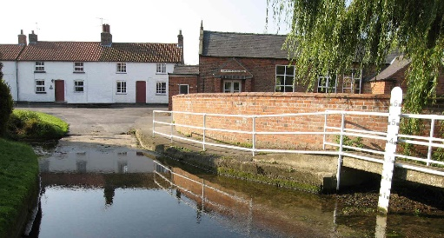 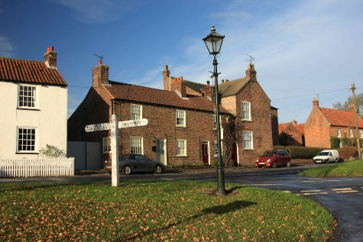 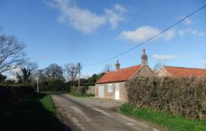

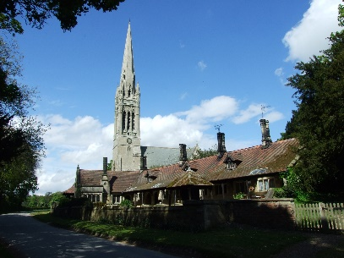 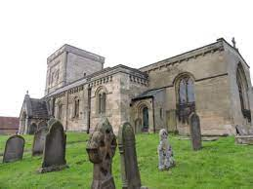 [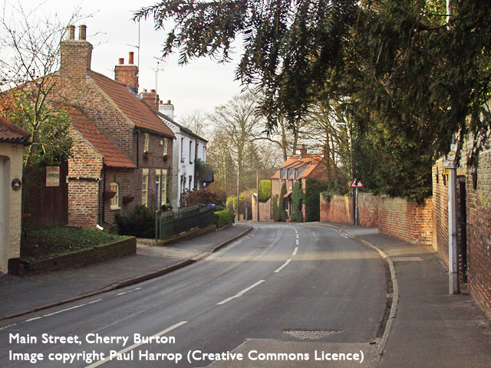](http://www.google.co.uk/url?sa=i&rct=j&q=&esrc=s&source=images&cd=&cad=rja&uact=8&ved=0ahUKEwjNzonr9YLSAhWFJMAKHatVA54QjRwIBw&url=http://eastriding.limehouse.co.uk/portal/forward_planning/allocations_dpd/suballoc?pointId=1362398798993&bvm=bv.146496531,d.ZGg&psig=AFQjCNE0tmosOkKDZI0CgZR7Q37npLdP7w&ust=1486726420329919)

**David Siddle**

**Rural Housing Enabler**

**East Riding of Yorkshire Council**

CONTENTS

1. PARISH SUMMARY 3

Lockington 3

Etton 3

Lund 4

Dalton Holme 4

Beswick 4

Cherry Burton 4

2. INTRODUCTION 4

3. AIM 4

4. SURVEY METHODOLOGY 5

5. HOUSING PROFILE OF THE BEVERLEY RURAL AREA 5

Population 5

Household Characteristics 6

Dwelling Stock 7

House Prices and Rental Values 8

6. KEY FINDINGS FROM THE HOUSING NEEDS SURVEY 10

QUESTION 1 10

QUESTION 2 13

QUESTION 3 14

QUESTION 4 17

QUESTION 5 18

QUESTION 6 19

QUESTION 7 20

QUESTION 8 22

QUESTION 9 22

QUESTION 10 23

QUESTION 11 25

7. SUMMARY AND RECOMMENDATIONS 25

RECOMMENDATIONS 26

Appendix 27

# PARISH SUMMARY

A map of the parishes and their boundaries is set out below:

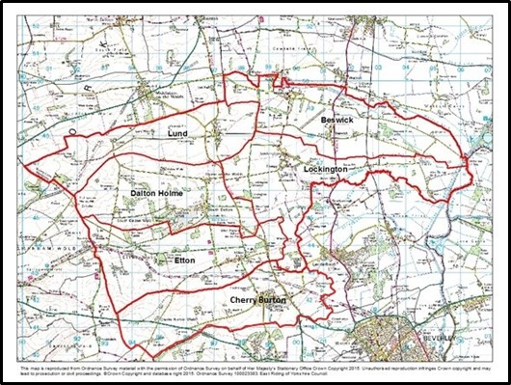

Figure 1: map of parish boundaries

The study comprised an area to the north/northwest of the market town of Beverley. It is predominantly rural and is situated between the lower dip slope of the Yorkshire Wolds and the flood plain of the River Hull. The six parishes in the study are part of the Beverley Rural ward, which in itself comprises 13 parishes. The study covered eight villages contained within these six parishes:

## Lockington

Lockington is a village of around 524 people (247 households) about 6 miles north of the large market town of Beverley and 8 miles south of the smaller town of Driffield. It lies between the A614 – an important route linking the hinterland around the city of Hull with the Wolds, the coast, and the surrounding area and the B1248 a road which cuts across to the High Wolds and the town of Malton beyond. Lockington is in an area dedicated to arable farming and ancillary businesses. The nearest main rail stations are at Beverley and Driffield. Local stations at Arram and Hutton Cranswick are each located about 5 miles away.

It has a well-used village hall, a well-regarded primary school and a church but no other significant commercial or community facilities. It is a ribbon village that follows the course of Bryan Mills Beck. The parish also contains the hamlets of Scorborough and Aike.

## Etton

Etton is a slightly smaller village lying to the west of Lockington with a population of about 277. It has a limited range of facilities, but it does have a pub and a church.

## Lund

Lund lies immediately to the west of Lockington and is a similar sized village to Etton with a population of 308. It too has no facilities other than a pub and church and is by-passed by the B1248.

## Dalton Holme

The parish of Dalton Holme comprises the two adjacent villages of South Dalton and Holme on the Wolds. Together they have a population of just 198. South Dalton is the larger village, and it too boasts a popular pub as well as a church with a magnificent spire. The villages lie just off the B1248 about two miles north of Etton and contains a large area of parkland which is part of the grounds of Dalton Hall.

## Beswick

The parish of Beswick also incorporates two villages – Kilnwick and Beswick. The latter lies just off the A614 and has little in the way of community facilities apart from a small school which it shares with the neighbouring village of Watton. Kilnwick lies to the north-west of Beswick but unlike its neighbour it does boast a thriving Community Park that acts as a hub for recreational activities within the village. Together the villages have a population of 357.

## Cherry Burton

The parish of Cherry Burton lies to the south of the area and has a population of 1392 (2011). It has a local shop as well as a pub and a popular primary school.

# INTRODUCTION

Affordable Housing is housing for either rent or low-cost home ownership based on evidence of need, for those unable to afford market prices. In order to help assess whether there is a need for Affordable Housing, the East Riding of Yorkshire Rural Housing Enabler (RHE) has completed a housing needs survey in the parishes of Lockington, Etton, Lund, Dalton Holme, Cherry Burton and Beswick. The RHE is a member of the wider North Yorkshire and East Riding Rural Housing Enabler Network and works with a range of organisations to help meet the housing needs of rural communities through the delivery of Affordable Housing.

Rural Housing Need Surveys record housing needs at a point in time and the RHE then uses this ‘snapshot’ of information as the basis of a report. This report can then be used as evidence to support a planning application for small local Affordable Housing developments. In the event that any new homes are built, priority would be given to applicants with a local connection to the parish, through family, residence or work, at the time the properties are allocated. This would take the form of a local letting policy or a local sales policy.

# AIM

The aim of the Housing Needs Survey (HNS) was to find out whether local people (or people with a local connection) are in housing need and are unable to access suitable housing to address their needs on the open market.

Housing ‘need’ can include issues other than merely the need for a home. It takes account of insecurity of tenure; affordability and housing that is unsuitable for the household due to its type or condition. It is different from housing demand because demand can normally be met though the housing market whereas need can usually only be met through some form of affordable (i.e. subsidised) housing.

This means that, in order to estimate the number of households in need, we want to identify households who do not have their own home or live in unsuitable housing and who cannot afford to meet their needs in the local market.

A household normally includes all who live in a particular house but can also include ‘newly forming’ households who currently live with a larger family/household (e.g. adult children living with parents).

# SURVEY METHODOLOGY

To carry out the HNS, several methods were employed:

* Emails were sent to all on the housing register who had expressed an interest in being rehoused in the six above mentioned parishes. The email included a link to the on-line questionnaire.
* Letters were posted to those who did not have email addresses (but who had also expressed an interest in those specific Beverley Rural villages).
* Leaflets were delivered through the doors of houses in Lockington, Etton, South Dalton, andHolme on the Wolds. These leaflets included a QR code that could enable the recipient to access the online survey.
* Announcements were made on local social media channels.
* Hard copies of the survey were available on request.
* The survey leaflets were distributed in week commencing 12th September with emails and letters posted out in the previous week. The deadline for returning the questionnaire was 30th September.
* Completed questionnaires were returned to the Council’s Consultation team for collation and initial analysis.

# HOUSING PROFILE OF THE BEVERLEY RURAL AREA

## Population

According to the 2011 Census, Lockington and the other parishes in the survey had a population of 1,664 forming 740 households. In 2001 there were a total of 1,685 people living in the villages and 712 households, a population decrease of around 1.2%, compared to an increase in the authority area as a whole of 6.5%. This may be attributable to the population aging and younger people moving away. At 33%, a significant proportion of the population is over the age of 60; this is also higher than the average for the East Riding as a whole (29.5%). A total of 252 people (15%) are aged 23-40 years and so would potentially qualify for Starter Homes if they were also first time buyers.

Figure 2: bar chart of population age profile

The population of the area is generally healthy although 7% describe their daily activities as being limited a lot. This is in comparison to the much higher figure of 10.3% in the East Riding local authority area as a whole.

## Household Characteristics

Almost two fifths of households within the area are couples with no children, while more than one quarter are single person households.

Table 1: Household characteristics

|  |  |
| --- | --- |
| **Living arrangement of household** | **Number of households (%)** |
| Couples with children | 24.1 |
| Couples without children | 39.2 |
| Singles with children | 6.4 |
| Singles without children/ one person | 26.2 |
| Other | 4.2 |

(*Source – Census 2011*)

Table 2: Dwelling bedrooms by percentage of household

|  |  |
| --- | --- |
| **Household Spaces** | **Number of households (%)** |
| 1 bedroom | 2.8 |
| 2 bedroom | 20.8 |
| 3 bedroom | 40.7 |
| 4 bedroom | 26.1 |
| 5 bedrooms or more | 9.6 |

(*Source: Census 2011*)

The majority of households live in 3 or 4 bedroom accommodation – a reflection of the preponderance of semi-detached and detached houses (see below). Less than one quarter of households live in a property with two bedrooms or fewer which may indicate an undersupply of smaller units.

## Dwelling Stock

Census data shows that more than half of all households live in detached properties, with around 1% living in flats.

Figure 3: Property type by household

In terms of tenure, 65.4% of homes in the parish area owned outright or with a mortgage. This is lower than the East Riding and the York and North Yorkshire region where the combined owned outright and owned with a mortgage are 75.3% and 71% respectively. There is a significant proportion of households that rent privately at 25%. This nearly doubles the percentage in the East Riding as a whole, where 13.7% of households rent from a private landlord.

A major factor in the privately rented sector is the presence of Dalton Estates (managing agents for the Hotham Family Trust) who own around 190 houses – all of which are let on assured tenancies.

In contrast, the area currently has a total of just 44 affordable properties, all of which are owned by East Riding of Yorkshire Council. These are a mixture of 2 and 3 bed houses and 1 and 2 bed bungalows.

The amount of social rented housing at 5.8% is significantly lower than the East Riding average of 9.7%. This is partly a product of higher-than-average levels of Right to Buy sales and partly the result of fewer houses for social rent being built in the first place.

Figure 4: Tenure by household

## House Prices and Rental Values

Asking prices for properties currently on the market within the area range from £295,000 to £750,000 (Rightmove, October 2022). The average asking price (£523,000) is not necessarily that meaningful because the sample size is low (10) and the range is very wide but it gives a general indication that house prices are significantly higher than average. The villages are covered by the Beverley Rural ward, where average prices are currently £333,891 based on Hometrack sales and valuations. In some villages average house prices are even higher; in Etton for instance, they are £570,750.

Assuming a 10% deposit is needed to secure a mortgage, a house price of say, £330,000 would mean that the average household would need to be earning approximately £84,850 per year to be able to afford to buy even the average priced house (calculation is based on an assumed average price £330000 – 10% (deposit) / 3.5 (mortgage multiplier).

The average price of sold properties in the last year is slightly lower at £309,793. Based on average sold prices, a household would have needed an income of £79,700 per year in order to purchase a property sold in the area in the last year (£310,000 – 10% deposit /3.5 mortgage multiplier).

At the present time (October 2022) there is only one property advertised on Right Move available to rent privately in the area – a two bed house advertised at £900 pcm. This is higher than the information on Hometrack which suggests a two-bedroom property in the area would cost around £138 per week (£598 pcm).

Added to this, the eight villages currently have a total of just 44 affordable properties. East Riding of Yorkshire Council own them all. There are 29 houses and just 15 bungalows. There is a mix of 2-bedroom houses and 3-bedroomed houses.

# KEY FINDINGS FROM THE HOUSING NEEDS SURVEY

A total of 159 completed survey forms were returned by the deadline.

## QUESTION 1

| **Do you have at least one of the following local connections to these parishes in Beverley Rural: Beswick, Cherry Burton, Dalton Holme, Etton, Lockington or Lund? (Please select all that apply)** | | | |
| --- | --- | --- | --- |
| **Answer Choices** | | | **Response Total** |
| 1 | I currently live in one of these parishes | |  | | --- | |  | | 43 |
| 2 | I currently work in one of these parishes for 20 hours or more per week | |  | | --- | |  | | 15 |
| 3 | I have close family (parents, grandparents, adult children, brother or sister) who have lived in one of these parishes for at least 5 years | |  | | --- | |  | | 43 |
| 4 | I have previously lived in one of these parishes for at least 6 out of the last 12 months, OR 3 out of the last 5 years | |  | | --- | |  | | 23 |
| 5 | I have no current connection to one of these parishes, but I am either a serving member of the Armed Forces OR have been discharged from the Armed Forces within the last 5 years | |  | | --- | |  | | 7 |
| 6 | I have no local connection to any of these parishes | |  | | --- | |  | | 75 |

Figure 5: Question 1 answers

There were 159 respondents to this question. Out of this number, 75 (47.2%) had no local connection to the Beverley Rural parishes. These households were not given the opportunity to complete the remainder of the survey because the survey was intended to focus on local housing needs only. Of the 124 responses who confirmed various local connections (from 84 respondents), 43 households lived in one of the parishes, 43 had close family in the village and 23 households had previously lived in the parish. Some respondents answered ‘yes’ to more than one local connection criteria. A more proportionate analysis of the responses is contained in the pie chart (Figure 6).

This shows that there is still a high percentage of respondents who have residence in one of the parishes, with those who have family coming in as the second most important local connection. Other local connections (work, former residence and armed forces links) are of subsiduary importance.

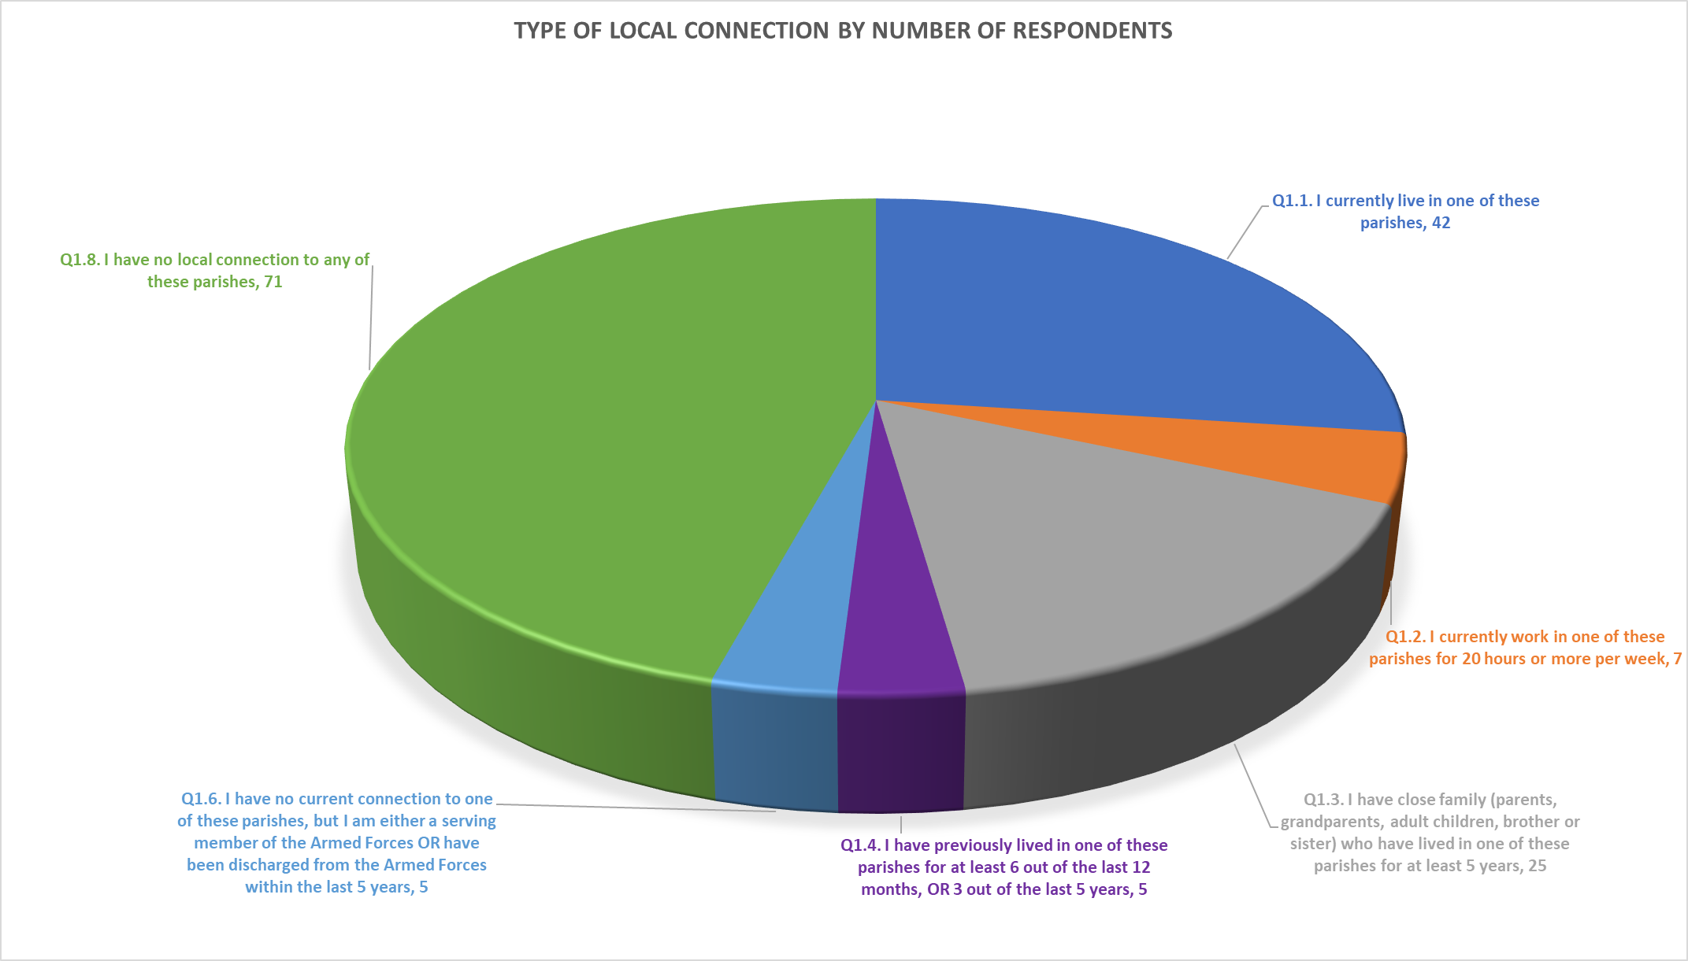Figure 6: types of local connection

## QUESTION 2

| **Which of the following Beverley Rural Parishes do you have local connection with?** | | | | |
| --- | --- | --- | --- | --- |
| **Answer Choices** | | | | **Response Total** |
| 1 | Beswick | |  | | --- | |  | |  | 12 |
| 2 | Cherry Burton | |  | | --- | |  | |  | 52 |
| 3 | Dalton Holme | |  | | --- | |  | |  | 9 |
| 4 | Etton | |  | | --- | |  | |  | 22 |
| 5 | Lockington | |  | | --- | |  | |  | 18 |
| 6 | Lund | |  | | --- | |  | |  | 11 |

Figure 7: Question 2 answers

The largest group of respondents have a local connection with Cherry Burton (52) with Etton (22) and Lockington (18) being in second and third place respectively. Once again there is some double counting and this is explained in the pie chart (Figure 8). Some respondents ticked more than one village to have a local connection to.

Figure 8: Number of villages respondents had connections to

## QUESTION 3

| **Why do you want/need to move? (Please select any that apply)** | | | | |
| --- | --- | --- | --- | --- |
| **Answer Choices** | | | | **Response Total** |
| 1 | Need a larger property | |  | | --- | |  | |  | 14 |
| 2 | Need a smaller property | |  | | --- | |  | |  | 15 |
| 3 | Cannot afford the rent/mortgage | |  | | --- | |  | |  | 26 |
| 4 | Forced to move (e.g. repossession, tenancy ending) | |  | | --- | |  | |  | 8 |
| 5 | Need housing suitable for older/disabled person | |  | | --- | |  | |  | 22 |
| 6 | To change tenure | |  | | --- | |  | |  | 4 |
| 7 | To be closer to family/friends to give/receive support | |  | | --- | |  | |  | 32 |
| 8 | To be closer to work/new job | |  | | --- | |  | |  | 13 |
| 9 | To be closer to facilities e.g. shops, doctors or transport links | |  | | --- | |  | |  | 7 |
| 10 | To be in a particular school catchment | |  | | --- | |  | |  | 2 |
| 11 | To move to a better neighbourhood/more pleasant environment | |  | | --- | |  | |  | 19 |
| 12 | To live with a partner | |  | | --- | |  | |  | 6 |
| 13 | Relationship breakdown | |  | | --- | |  | |  | 3 |
| 14 | I’d like a place of my own | |  | | --- | |  | |  | 17 |
| 15 | Other (please specify): | |  | | --- | |  | |  | 14 |
| Other (please specify): (14) | | | | |
| |  |  | | --- | --- | | 1 | Medical discharge from Armed Forces | | 2 | Mental disability | | 3 | I live in a Caravan , have serious health issues | | 4 | We are current residents and wish to highlight possible problem areas regarding house building in Beverley Rural Villages. | | 5 | I want to buy a home in Etton but all the houses are unaffordable | | 6 | I live in Leconfield in a private rental, not sure why Leconfield isn’t on this list given it’s proximity to cherry burton. I rent a private tenancy that is ending and I can no longer afford the £1000 rent a week. | | 7 | nearer partner | | 8 | homeless currently | | 9 | currently living with daughter temporarily | | 10 | smaller garden | | 11 | support needs | | 12 | poor health | | | | | |

Figure 9: Question 3 responses

The reasons for wanting to move are multi-faceted but the main factors are ‘to be closer family and friends to provide/receive support’; ‘can’t afford the rent/mortgage’; ‘need a larger property’; ‘I’d like a place of my own’ and ‘to move to a better neighbourhood/more pleasant environment’.

There is clear evidence amongst those with local connections that they are seeking more suitable alternative accommodation. This may be because of social care reasons; need to secure more affordable housing or a need to get something that fits a person’s needs and aspirations in general.

Figure 10: Criteria of need

## QUESTION 4

| **Please tell us the ages of the people who will be living in your next home (If there are more than 5, then please answer for the 5 oldest members)** | | | | | | |
| --- | --- | --- | --- | --- | --- | --- |
| **Answer Choices** | **Person 1** | **Person 2** | **Person 3** | **Person 4** | **Person 5** | **Response Total** |
| 10 years and under | 44.0% 11 | 32.0% 8 | 12.0% 3 | 8.0% 2 | 4.0% 1 | 25 |
| Between 11 and 18 | 40.0% 4 | 40.0% 4 | 20.0% 2 | 0.0% 0 | 0.0% 0 | 10 |
| Between 19 and 30 | 52.5% 21 | 27.5% 11 | 17.5% 7 | 2.5% 1 | 0.0% 0 | 40 |
| Between 31 and 40 | 50.0% 3 | 33.3% 2 | 0.0% 0 | 0.0% 0 | 16.7% 1 | 6 |
| Between 41 and 50 | 42.9% 6 | 42.9% 6 | 7.1% 1 | 0.0% 0 | 7.1% 1 | 14 |
| Between 51 and 60 | 50.0% 5 | 40.0% 4 | 0.0% 0 | 10.0% 1 | 0.0% 0 | 10 |
| 60 years and older | 63.5% 28 | 36.4% 16 | 0.0% 0 | 0.0% 0 | 0.0% 0 | 44 |

Figure 11: Question 4 responses

Figure 12: Make up of respondent households

The statistics reveal a wide age range but with particular emphasis on younger adults (19-30 years-old) and older persons (over 60). There is a bias towards single persons and couples.

Figure 13: households including 18 and under age group

## QUESTION 5

|  |  |  |  |  |
| --- | --- | --- | --- | --- |
| **Please tell us the minimum number of bedrooms you require.** | | | | |
| **Answer Choices** | | | **Response Percent** | **Response Total** |
| 1 | 1 | |  | | --- | |  | | 22.9% | 19 |
| 2 | 2 | |  | | --- | |  | | 55.4% | 46 |
| 3 | 3 | |  | | --- | |  | | 18.1% | 15 |
| 4 | 4 or more | |  | | --- | |  | | 3.6% | 3 |

Figure 14: Question 5 responses

These answers reveal a preference for 2 bedroomed accommodation with both one bed and three bed having nearly two thirds less interest (both being broadly equally popular in their own right).

## QUESTION 6

| **Which type(s) of accommodation would you consider? (Please select all that apply)** | | | | | | |
| --- | --- | --- | --- | --- | --- | --- |
| **Answer Choices** | | |  | | **Response Total** | |
| 1 | Flat | |  | | --- | |  | | |  | | 26 |
| 2 | House | |  | | --- | |  | | |  | | 66 |
| 3 | Bungalow | |  | | --- | |  | | |  | | 65 |
| 4 | Sheltered / Extra Care accommodation | |  | | --- | |  | | |  | | 10 |

Figure 15: Question 6 responses

Both houses and bungalows are equally popular and dominate the responses. Flats make up just over 16% of respondents – presumably from single persons and couples. There is a small minority of older persons who would also consider sheltered or extra care accommodation.

Figure 16: accommodation type preferences

## QUESTION 7

| **Do you need any special adaptations to a property? (Please select all that apply)** | | | | |
| --- | --- | --- | --- | --- |
| **Answer Choices** | | | **Response Percent** | **Response Total** |
| 1 | Through floor lift |  |  | 0 |
| 2 | Ramped access | |  | | --- | |  | |  | 4 |
| 3 | Level access shower | |  | | --- | |  | |  | 17 |
| 4 | Stairlift |  |  | 0 |
| 5 | Overbath shower | |  | | --- | |  | |  | 11 |
| 6 | Remote door entry |  |  | 0 |
| 7 | I have no needs for special adaptations | |  | | --- | |  | |  | 42 |
| 8 | Other (please give details below): | |  | | --- | |  | |  | 8 |
| Other (please give details below): (8) | | | | |
| |  |  | | --- | --- | | 1 | Stair bannister hand rails near bath | | 2 | I am a vulnerable person | | 3 | Grab rails at front and back door | | 4 | Wide doorways | | 5 | back problems so struggle with stairs and bath | | 6 | handles by bath/toilet | | 7 | No stairs | | 8 | wide doorways/handrails | | | | | |

Figure 17: Question 7 responses

Some respondents have identified special needs and adaptation requirements, in particular showers (either level access or over the bath). Other requests included aids to mobility including grab rails, handrails and ramped access.

Figure 19: Type of adaptations required

## QUESTION 8

| **Are you a member of a newly formed household (e.g. moving out of the family home, living with friends/partner, moving out for the first time) looking for your first property to rent or buy?** | | | | |
| --- | --- | --- | --- | --- |
| **Answer Choices** | | | **Response Percent** | **Response Total** |
| 1 | Yes | |  | | --- | |  | | 27.7% | 23 |
| 2 | No | |  | | --- | |  | | 72.3% | 60 |

Figure 20: Question 8 responses

Just over one quarter of the respondents have identified themselves as newly forming households. This sector of the population have particular problems accessing decent housing at an affordable price

## QUESTION 9

| **Regarding your current home, please tell us whether you are:** | | | | |
| --- | --- | --- | --- | --- |
| **Answer Choices** | | | **Response Percent** | **Response Total** |
| 1 | An owner occupier with a mortgage | |  | | --- | |  | | 6.3% | 5 |
| 2 | An owner occupier without a mortgage | |  | | --- | |  | | 7.5% | 6 |
| 3 | Renting a Council property | |  | | --- | |  | | 12.5% | 10 |
| 4 | Renting via a Housing Association | |  | | --- | |  | | 7.5% | 6 |
| 5 | Renting privately | |  | | --- | |  | | 38.8% | 31 |
| 6 | Living with family or friends | |  | | --- | |  | | 27.5% | 22 |
| 7 | None of the above (please give details) |  | 0.0% | 0 |
| None of the above (please give details) (0) | | | | |

Figure 21: Question 9 responses

This question reveals that most of those in housing need are either in the privately rented sector or are living with family or friends (nearly two thirds).

## QUESTION 10

| **Would you consider any of the following forms of low-cost home ownership as well as affordable rented housing? (Please tick any that apply)** | | | | | | |
| --- | --- | --- | --- | --- | --- | --- |
| **Answer Choices** | | | | **Response Total** | |
| 1 | Shared Ownership – where you can flexibly purchase a share of the property as low as 10% and rent the remainder | |  | | --- | |  | |  | | 24 |
| 2 | First Homes – where you acquire the house but buy and sell at a fixed discount of 30% of the market value. | |  | | --- | |  | |  | | 22 |
| 3 | Rent to Buy – where you rent to begin with and have an option to purchase at a later date | |  | | --- | |  | |  | | 38 |

Figure 22: Question 10 responses

This question reveals that there is considerable interest in the different low-cost home ownership options.

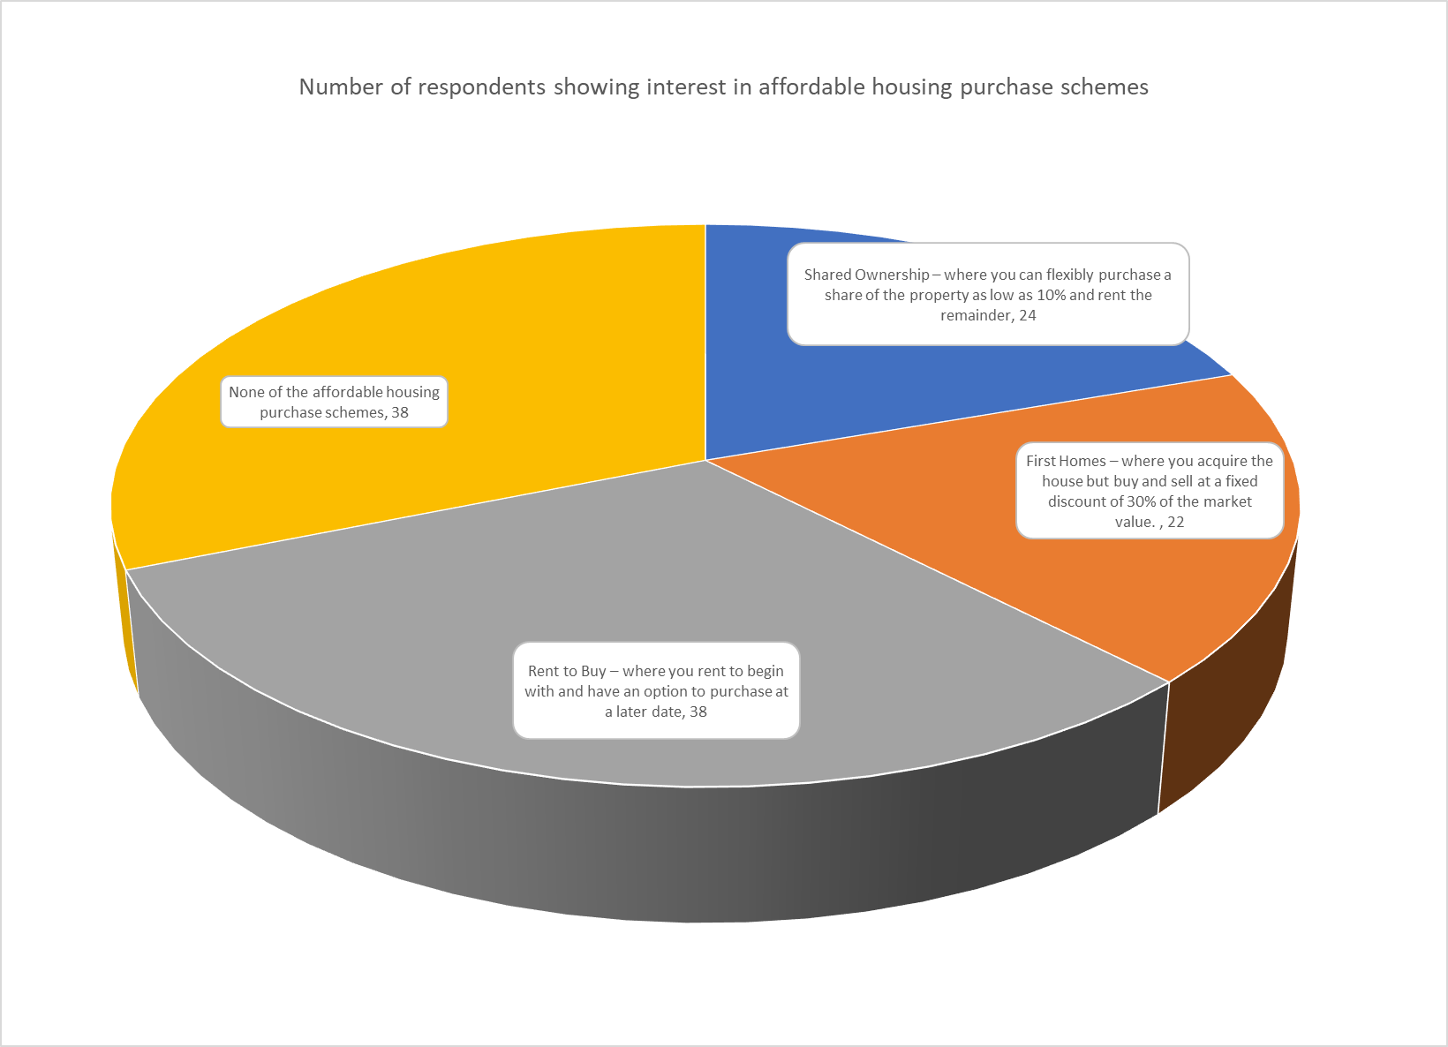

Figure 23: Interest in affordable housing schemes

## QUESTION 11

| **Are you currently on the Council's register for housing?** | | | | | | |
| --- | --- | --- | --- | --- | --- | --- |
| **Answer Choices** | | | **Response Percent** | | **Response Total** | |
| 1 | Yes | |  | | --- | |  | | | 64.3% | | 54 |
| 2 | No | |  | | --- | |  | | | 35.7% | | 30 |

Figure 24: respondents on the housing register

Whilst there are many on the housing register (nearly two thirds) a significant number have not applied for Council housing, but are clearly looking for alternative housing that they can afford to live in.

# SUMMARY AND RECOMMENDATIONS

The survey reveals that there are chronic unmet housing needs in the Beverley Rural area. These conclusions echo those that were contained in the Beverley Rural housing market report of 2021 and earlier housing needs reports in the Lockington/Etton area in 2018 and Cherry Burton in 2017.

In total 159 questionnaires were returned and completed, of which 84 were from households with a local connection. The survey incorporated either email or postal delivery to every household who has their name on the housing register and who had indicated an interest in being rehoused in the survey area. In addition, leaflets were hand delivered to all houses in Etton, Lockington, Holme on the Wolds and South Dalton. The leaflet encouraged completion of the survey via a QR code (or alternatively, paper copies of the survey could be requested). Some social media outlets were also used to publicise the survey.

Overall, the response rate is very good for this type of survey.

The survey shows that there are locally based households (or those with local connections to the village) who do have unmet housing needs that require to be met by affordable rented housing or low-cost home ownership.

House prices are clearly unaffordable to most households but newly emerging households and first time buyers are particularly badly affected by a dysfunctional housing market that can no longer cater for the community’s needs as a whole. The survey showed that over one quarter of respondents identified themselves as newly forming households.

Should housing needs be identified through local housing needs surveys then it is normally assumed that any ensuing development should err on the side of caution and make provision for around 50% of the needs.

This would mean that villages such as Etton and Lockington, where some of the highest demand was evident, would benefit from upto 8-10 new affordable homes each. This number could increase if the needs of adjacent villages are considered.

It is apparent that Cherry Burton has significantly higher needs although this is in proportion to the higher population of this parish. It should be noted that this is the only village in the cluster to have an allocated market housing site and this site may deliver a small number of affordable housing units in compliance with any s106 agreement between developer and the local authority.

It should be noted that South Dalton, Holme on the Wolds (both in Dalton Holme parish) and Beswick are villages that don’t have development limits and are therefore regarded as situated in open countryside. Housing sites here would not be appropriate as any new development would not meet LP policy. Furthermore, the parish of Lund did not show itself to have significant housing need and therefore is not thought to be a priority for new affordable housing.

Given the spread of the survey, with survey forms being distributed to a range of villages, there is no guarantee that a household in housing need would necessarily move to an adjacent village. However, some villages are relatively close to each other and have strong links (e.g., Etton and Cherry Burton) and so these concerns may be overcome. In addition, households seeking to buy may be a little more flexible in terms of the geographic range of their housing search

The report’s recommendations are as follows.

## RECOMMENDATIONS

1. Additional affordable housing is required to provide well managed and accessible housing for those sectors in the community unable to access private housing for sale and who wish to remain in the Beverley Rural area for reasons of residency, family needs or employment.
2. Small sites (of up to 8/10 units) on the edges of the development limits of Lockington, Etton and Cherry Burton where the highest needs have been demonstrated should be identified in partnership with local housing providers. These could either be Rural Exception or First Homes exception sites.
3. Particular emphasis should be placed on the following house types and tenures
   1. Small scale schemes of housing for low-cost home ownership (Shared Ownership; First Homes; and Rent to Buy); preferably either 2 or 3 bedroomed housing.
   2. Small scale schemes of housing for affordable or social rent for families and smaller households including schemes for older persons.
   3. Consideration should be given to mixed tenure schemes where appropriate.
4. Any such scheme should be linked to a local lettings or local sales policy to ensure that local households are given the highest priority in any allocation or sales process and that these conditions are established ‘in perpetuity’.
5. As well as possible sites in Lockington and Etton, further consideration should be given to a small affordable site in Cherry Burton to supplement the market site in the village.

# Appendix

**Beverley Rural Ward**

**Housing Needs Survey**

**Introduction**

East Riding Council's Housing Strategy Team is looking to get more information about the demand for affordable housing in Beverley Rural. To enable us to do this, we have devised this short survey of 12 questions.

If you are struggling to find a home in the Beverley Rural area that is suitable and affordable we want to hear from you.

In addition to people already on the Council's waiting list for this area, we also want to hear from people who are not on the waiting list.

If you are adequately housed, then this survey is not for you personally, but you may know of others within Beverley Rural: Beswick, Cherry Burton, Dalton Holme, Etton, Lockington or Lund who are struggling to find affordable housing in the village. If so, we would really appreciate it if you could make them aware of this survey.

Closing date: Friday 30th September 2022

Further Information

This survey can be made available in other languages or formats if required. To request another format, please contact David Siddle at:

Telephone: 07711 808298

Email: david.siddle@eastriding.gov.uk

Data Protection

The information you provide in this consultation will be anonymous and kept confidential by East Riding of Yorkshire Council in accordance with the Data Protection Act 2018.

To see the privacy notice related to consultation please see the consultation privacy notice.

The Council uses SmartSurvey's software to create and administer the majority of its surveys. All survey responses are managed through SmartSurvey sub-processors, where data is stored securely by robust security features. Data held on the SmartSurvey platform will be retained for up to 6 weeks following the end of the consultation.

Details of SmartSurvey’s own privacy policy can be found on their website: <https://www.smartsurvey.co.uk/privacy-policy>

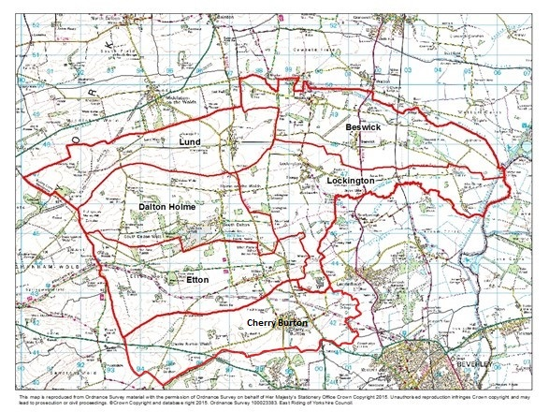

**Do you have at least one of the following local connections to these parishes in Beverley Rural: Beswick, Cherry Burton, Dalton Holme, Etton, Lockington or Lund?**  
(Please select all that apply) **\***

|  |  |
| --- | --- |
|  | I currently live in one of these parishes |
|  | I currently work in one of these parishes for 20 hours or more per week |
|  | I have close family (parents, grandparents, adult children, brother or sister) who have lived in one of these parishes for at least 5 years |
|  | I have previously lived in one of these parishes for at least 6 out of the last 12 months, OR 3 out of the last 5 years |
|  | I have no current connection to one of these parishes, but I am either a serving member of the Armed Forces OR have been discharged from the Armed Forces within the last 5 years |
|  | I have no local connection to any of these parishes |

**If you do not have any local connection to any of these parishes, please discontinue the survey. Thank you**

**Which of the following Beverley Rural Parishes do you have local connection with?**

|  |  |
| --- | --- |
|  | Beswick |
|  | Cherry Burton |
|  | Dalton Holme |
|  | Etton |
|  | Lockington |
|  | Lund |

**Why do you want/need to move?**  
(Please select any that apply)

|  |  |
| --- | --- |
|  | Need a larger property |
|  | Need a smaller property |
|  | Cannot afford the rent/mortgage |
|  | Forced to move (e.g., repossession, tenancy ending) |
|  | Need housing suitable for older/disabled person |
|  | To change tenure |
|  | To be closer to family/friends to give/receive support |
|  | To be closer to work/new job |
|  | To be closer to facilities e.g., shops, doctors or transport links |
|  | To be in a particular school catchment |
|  | To move to a better neighbourhood/more pleasant environment |
|  | To live with a partner |
|  | Relationship breakdown |
|  | I’d like a place of my own |
|  | Other (please specify):   |  | | --- | |  | |

**Please tell us the ages of the people who will be living in your next home (If there are more than 5, then please answer for the 5 oldest members)**

|  | Person 1 | Person 2 | Person 3 | Person 4 | Person 5 |
| --- | --- | --- | --- | --- | --- |
| 10 years and under |  |  |  |  |  |
| Between 11 and 18 |  |  |  |  |  |
| Between 19 and 30 |  |  |  |  |  |
| Between 31 and 40 |  |  |  |  |  |
| Between 41 and 50 |  |  |  |  |  |
| Between 51 and 60 |  |  |  |  |  |
| 60 years and older |  |  |  |  |  |

**Please tell us the minimum number of bedrooms you require.**

|  |  |
| --- | --- |
|  | 1 |
|  | 2 |
|  | 3 |
|  | 4 or more |

**Which type(s) of accommodation would you consider?**  
(Please select all that apply)

|  |  |
| --- | --- |
|  | Flat |
|  | House |
|  | Bungalow |
|  | Sheltered / Extra Care accommodation |

**Do you need any special adaptations to a property?**  
(Please select all that apply)

|  |  |
| --- | --- |
|  | Through floor lift |
|  | Ramped access |
|  | Level access shower |
|  | Stairlift |
|  | Overbath shower |
|  | Remote door entry |
|  | I have no needs for special adaptations |
|  | Other (please give details below):   |  | | --- | |  | |

**Are you a member of a newly formed household (e.g. moving out of the family home, living with friends/partner, moving out for the first time) looking for your first property to rent or buy?**

|  |  |
| --- | --- |
|  | Yes |
|  | No |

**Regarding your current home, please tell us whether you are:**

|  |  |
| --- | --- |
|  | An owner occupier with a mortgage |
|  | An owner occupier without a mortgage |
|  | Renting a Council property |
|  | Renting via a Housing Association |
|  | Renting privately |
|  | Living with family or friends |
|  | None of the above (please give details)   |  | | --- | |  | |  | |

**Would you consider any of the following forms of low-cost home ownership as well as affordable rented housing?**  
(Please tick any that apply)

|  |  |
| --- | --- |
|  | Shared Ownership – where you can flexibly purchase a share of the property as low as 10% and rent the remainder |
|  | [First Homes](https://www.which.co.uk/money/mortgages-and-property/first-time-buyers/first-homes-scheme-anc691g9xc63) – where you acquire the house but buy and sell at a fixed discount of 30% of the market value. |
|  | Rent to Buy – where you rent to begin with and have an option to purchase at a later date |

**Are you currently on the Council's register for housing?**

|  |  |
| --- | --- |
|  | Yes |
|  | No |

**Please provide your full postcode:**  
(This will help us to see if residents from other areas have different views)

|  |
| --- |
|  |

**About you ...**

It is important to us to know whether we are supporting or providing services fairly to all groups of people. These questions are intended to help us to find out about that.

The information you give us will be kept confidentially and stored securely and will only be used to monitor the fairness and effectiveness of our service delivery and employment practices. No personal information which can identify you, such as your name or address, will be used in producing equality reports.

**You do not have to complete this form or some of the questions if you do not want to and it will not affect your access to services or how we treat you.**

Thank you.

**Please indicate your age group:**

|  |  |
| --- | --- |
|  | Under 18 years |
|  | 18 to 24 years |
|  | 25 to 44 years |
|  | 45 to 64 years |
|  | 65 to 74 years |
|  | 75 to 84 years |
|  | 85 years or over |
|  | Prefer not to say |

**Are you:**

|  |  |
| --- | --- |
|  | Male |
|  | Female |
|  | Non-binary |
|  | Prefer not to say |
|  | Other (please specify):   |  | | --- | |  | |

**Do you:**

|  |  |
| --- | --- |
|  | Consider myself to be trans |
|  | Do not consider myself to be trans |
|  | Prefer not to say |

**Do you consider yourself to have a disability?  
  
Note - The Equality Act 2010 considers a person to be disabled if they have a "physical or mental impairment that has a substantial and long-term adverse effect on their ability to carry out normal day-to-day activities". You do not need to be registered disabled.**

|  |  |
| --- | --- |
|  | Yes (please state below) |
|  | I need adjustments (please state below) |
|  | No |
|  | Prefer not to say |

Comments:

|  |
| --- |
|  |

**Where did you hear about this consultation?**

|  |
| --- |
|  |

|  |  |
| --- | --- |
|  | Social media |
|  | Council website |
|  | Postcard/Poster |
|  | Word of mouth |
|  | Other (please state) |
|  |  |

If other, please state:

|  |
| --- |
|  |

**You have completed this survey!**

Thank you for taking the time to answer this survey.